**Experiment No : 3**

**Aim:** To build up K-means & Hierarchical Clustering Models.

**Theory:**

**Clustering: Clustering** is a Machine Learning technique that involves the grouping of data points. Data points that are in the same group should have similar properties and/or features, while data points in different groups should have highly dissimilar properties and/or features.

**K-means Clustering**- K-means clustering is a type of unsupervised learning, which is used when you have unlabelled data (i.e., data without defined categories or groups). The goal of this algorithm is to find groups in the data, with the number of groups represented by the variable K.

**Hierarchical Clustering -** Hierarchical clustering is a powerful technique that allows you to build tree structures from data similarities.

I have used Statistics and Machine Learning Toolbox for performing Clustering.

**Code 1: K-means Clustering**

clc; clear all; close all;

k = csvread('CSV_Features_24.csv');

knew = zeros(150,24);

knew(1:50,:) = k(1:50,:);

knew(51:100,:) = k(51:100,:);

knew(101:150,:) = k(101:150,:);

[cidx3,cmeans3] = kmeans(knew,3,'replicates',15,'display','final');

figure('Name','K-Means Silhoutte')

[silh3,h] = silhouette(knew,cidx3,'sqeuclidean');

**Dataset used :** CSV files with clustering feature data

**Output 1 :**

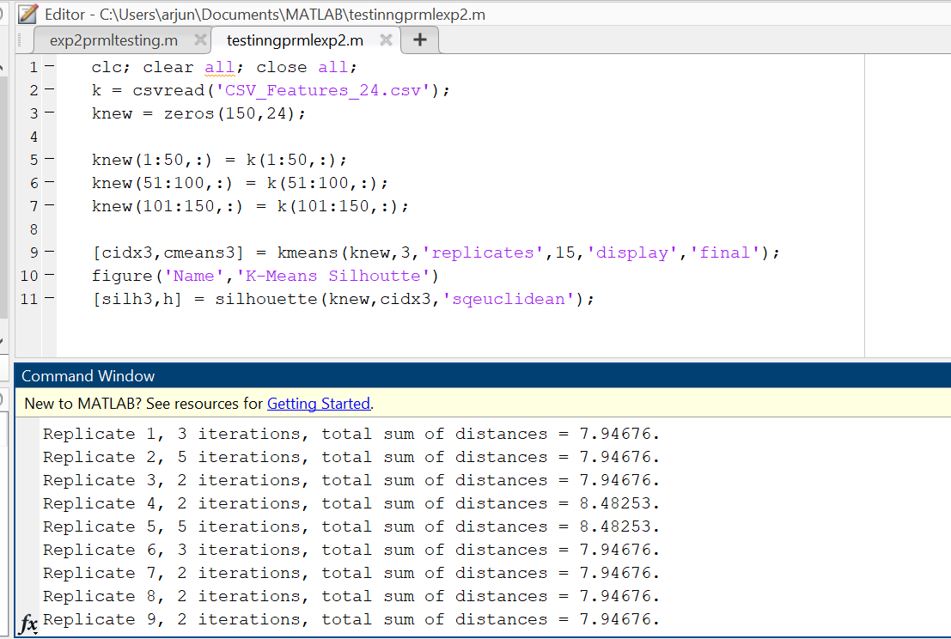

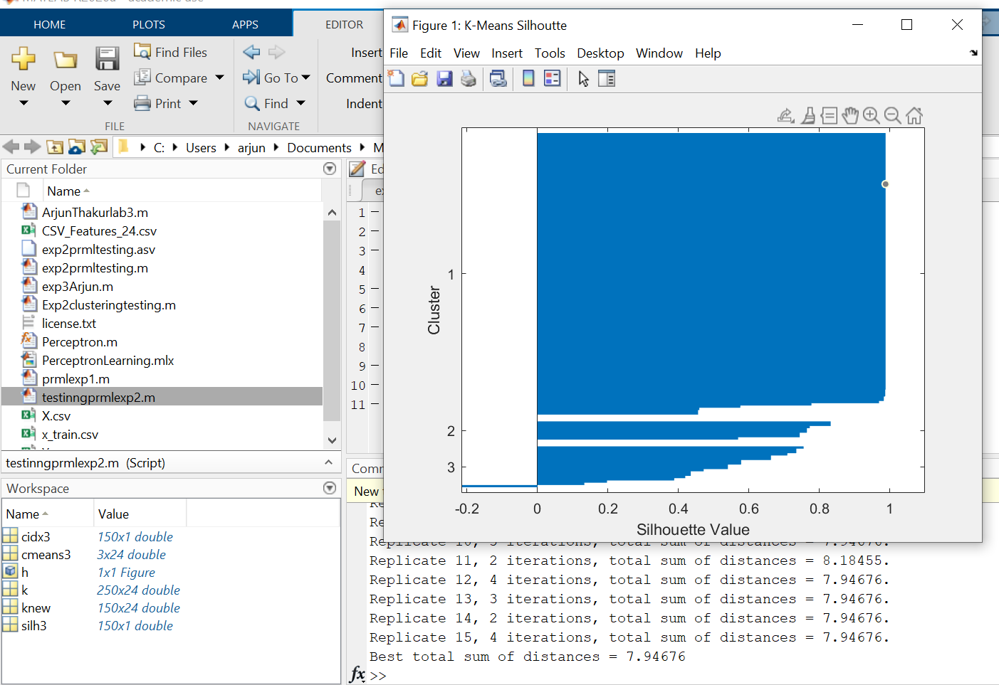

**Code 2: Hierarchical Clustering**

k = csvread('CSV_Features_24.csv');

knew = zeros(150,24);

knew(1:50,:) = k(1:50,:);

knew(51:100,:) = k(51:100,:);

knew(101:150,:) = k(101:150,:);

X = pdist(knew,'euclidean');

Z = linkage(X,'average');

cutoff = median([Z(end-2,3) Z(end-1,3)]);

figure('Name','Hierarchial Tree')

dendrogram(Z,'ColorThreshold',cutoff)

**Output 2:**

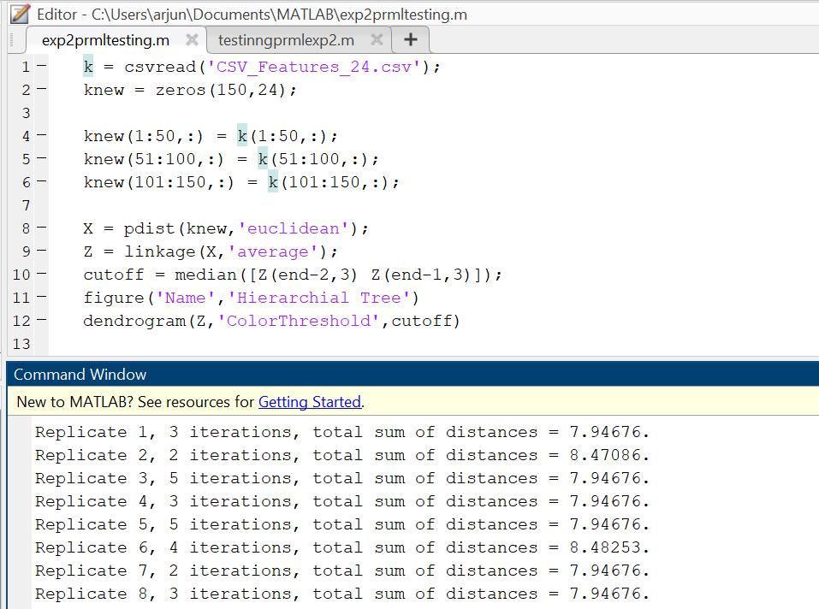

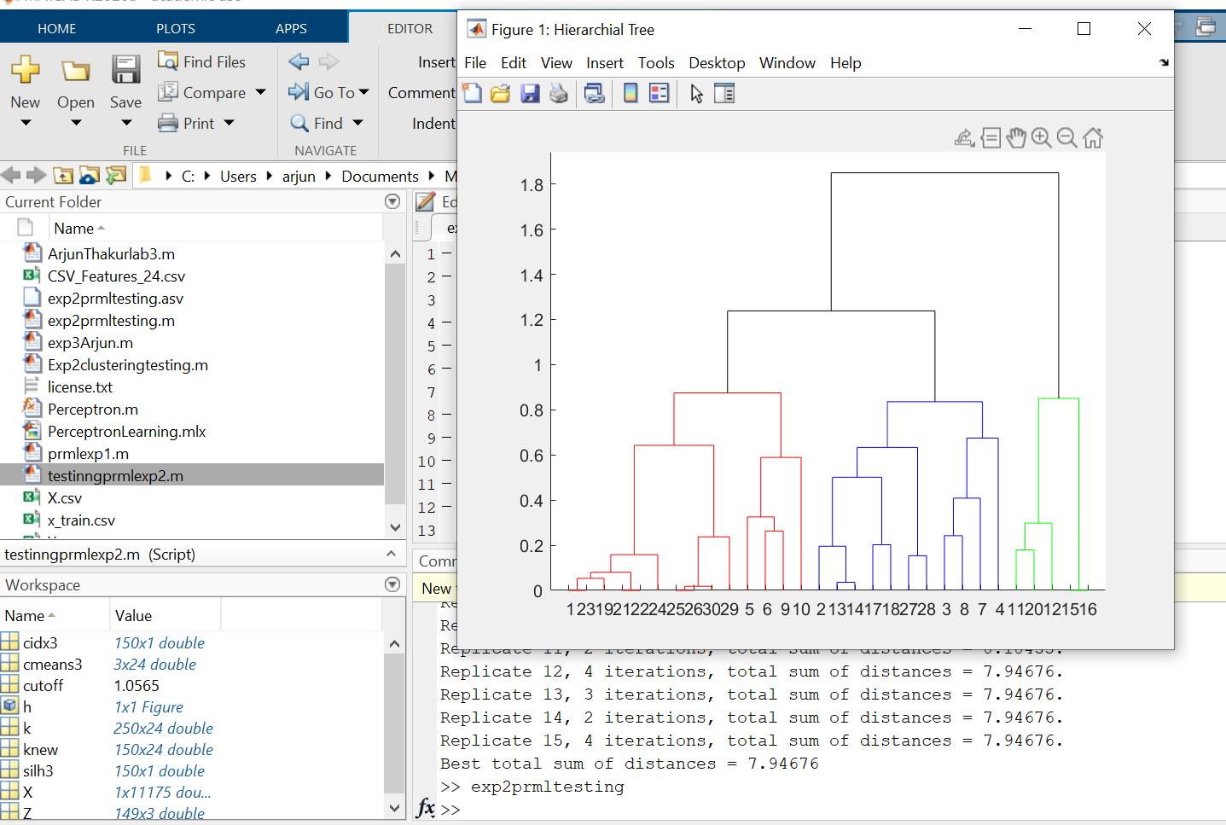

**Conclusion** : Therefore, I have understood about unsupervised learning (Clustering) in more depth to perform K- means Clustering and Hierarchical Clustering on MATLAB software.